**Defect 1: Browser Compatibility Defect: Unable to Vote from Firefox (V97.0.2) and Safari browsers**

**Steps to reproduce:**

**Scenario 1**

1. Navigate to <https://buggy.justtestit.org> on Firefox browser
2. Click on Popular Model image

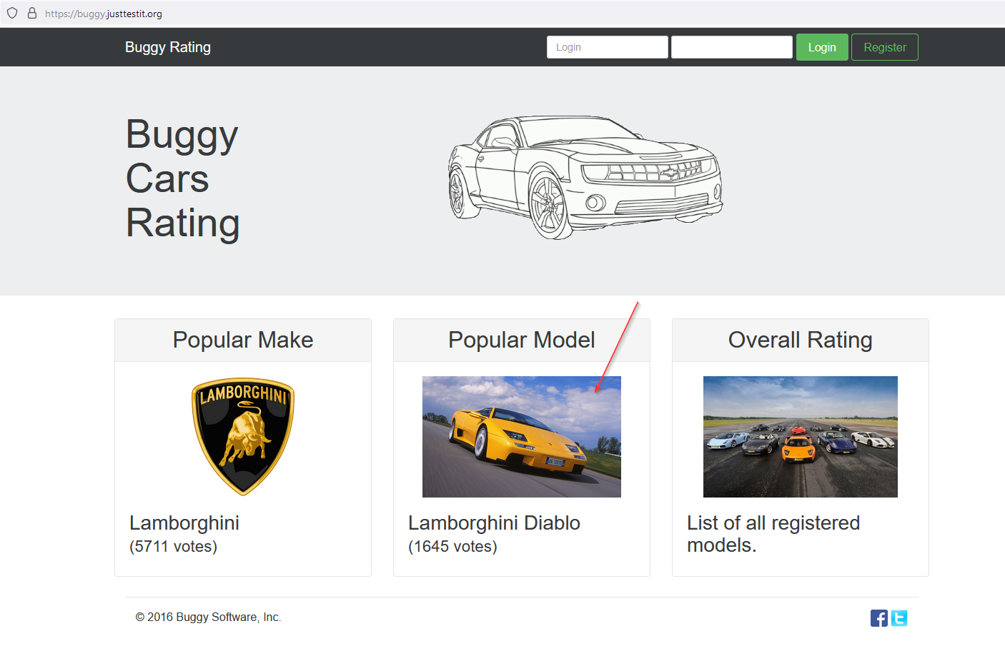

**Actual Behaviour:**

Page starts to load but never finishes loading. We see the Blue spinner spinning forever

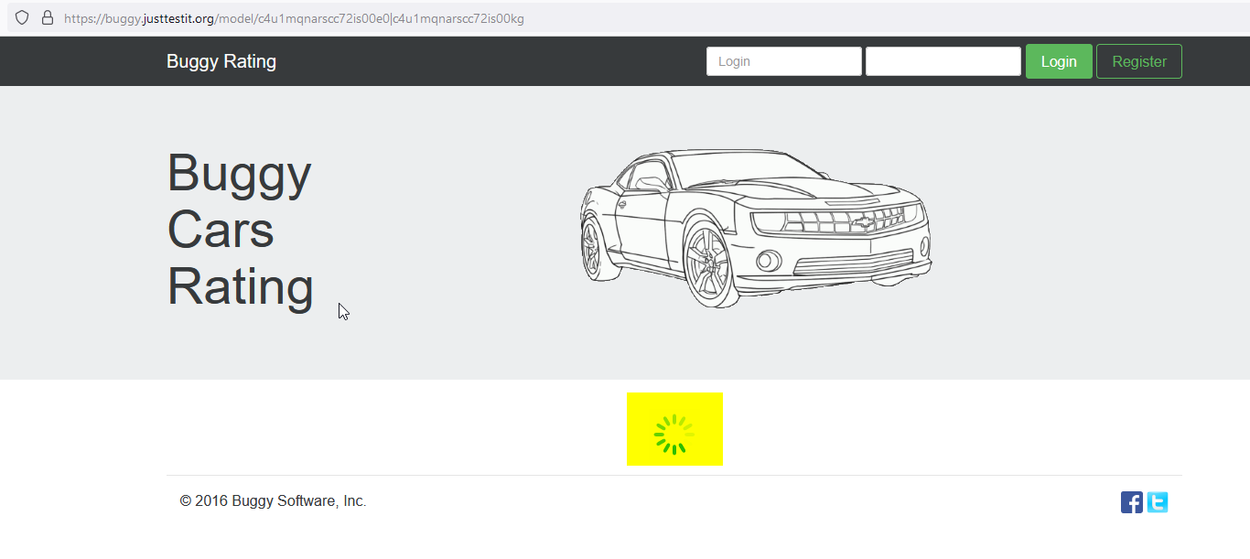

**Expected Behaviour:**

Popular Model page should load just like in Chrome browser.

**Impact:**

Firefox users and Safari users are not able to navigate to Popular Model page and are not able to vote ,which is main feature of this web application .Neither they are able to use any of the functionalities available on that page.

**Scenario 2:**

Same issue is observed when navigating from Overall Rating-> click on any car model

**Defect 2: Nothing happens on clicking Logout button**

**Steps to reproduce:**

1. login from the Home Page, click on Overall Rating image
2. Vote for any 1 Car Model and click on back arrow(as highlighted)

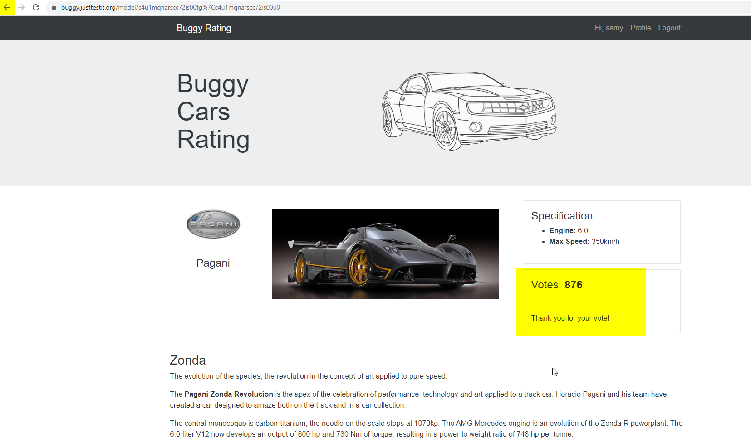

1. vote for some other car model and click on Back arrow

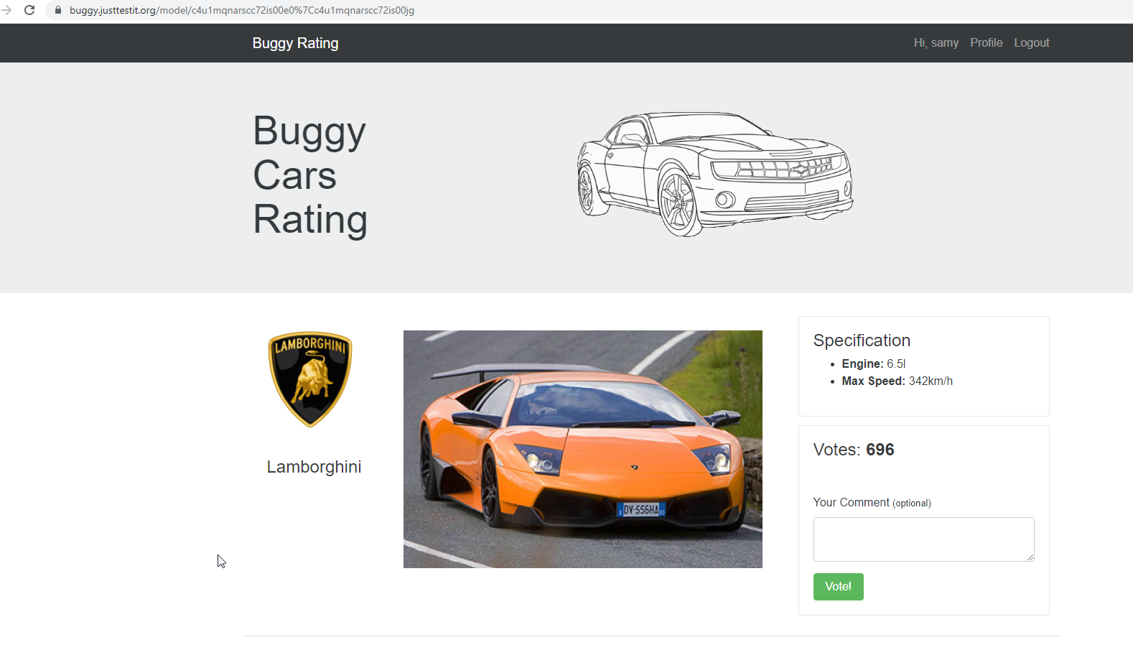

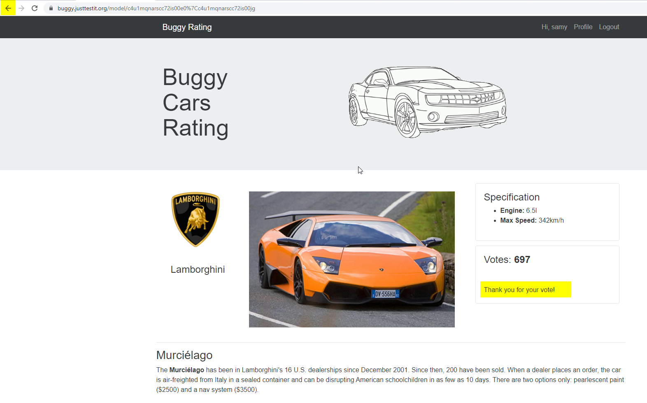

1. click on Logout

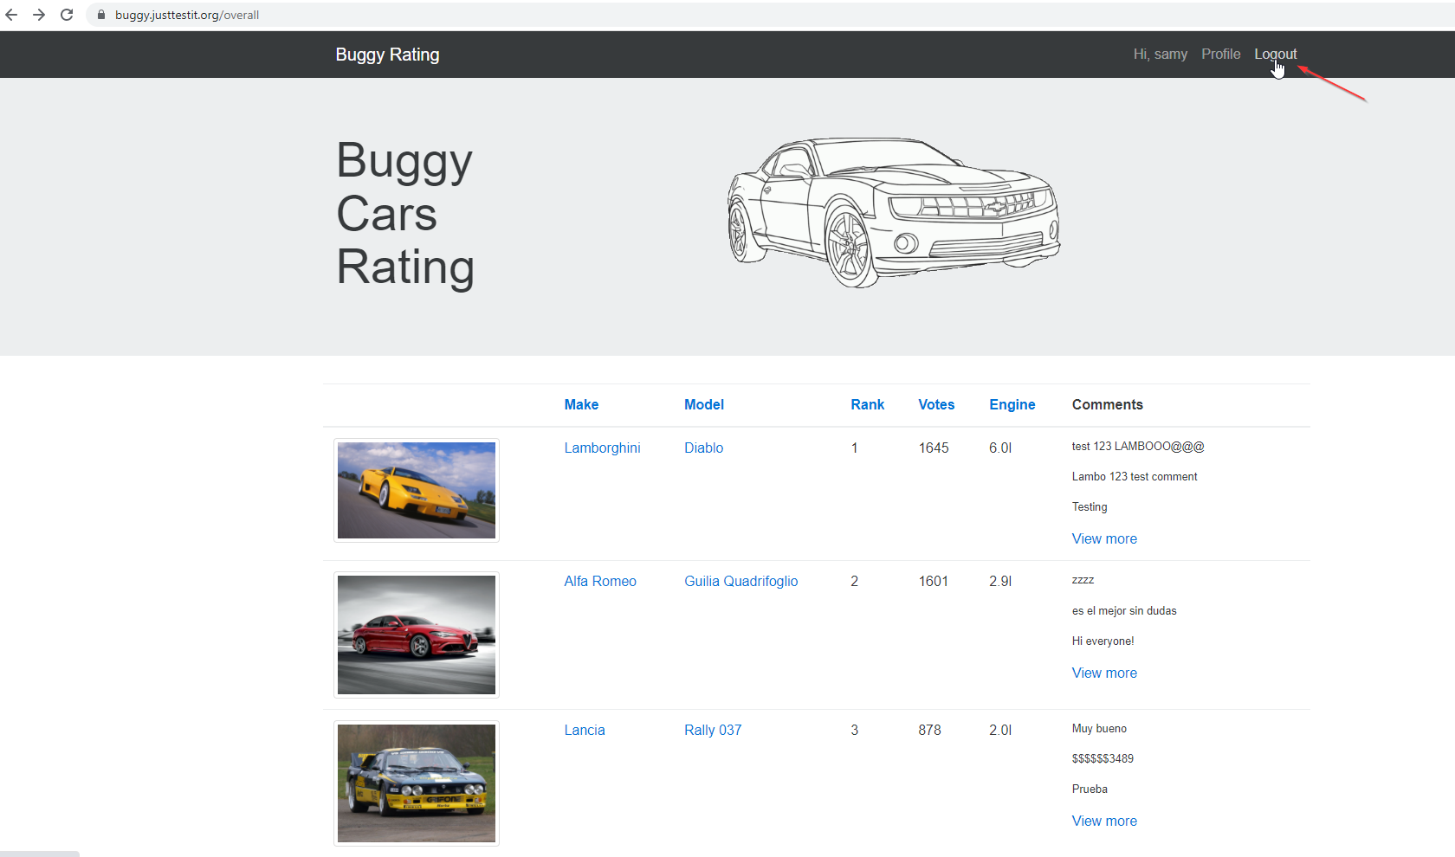

**Current Behaviour:**

Nothing happens, Logout button becomes non responsive, user does not get logged out of the website

**Expected Behaviour:**

User should log out, on clicking Logout

**Defect 3: Blank Home Page gets displayed**

**Steps to reproduce:**

1. From the Home Page(do not login), click on Overall Rating image
2. navigate to the 4th page and click on Lancia as highlighted

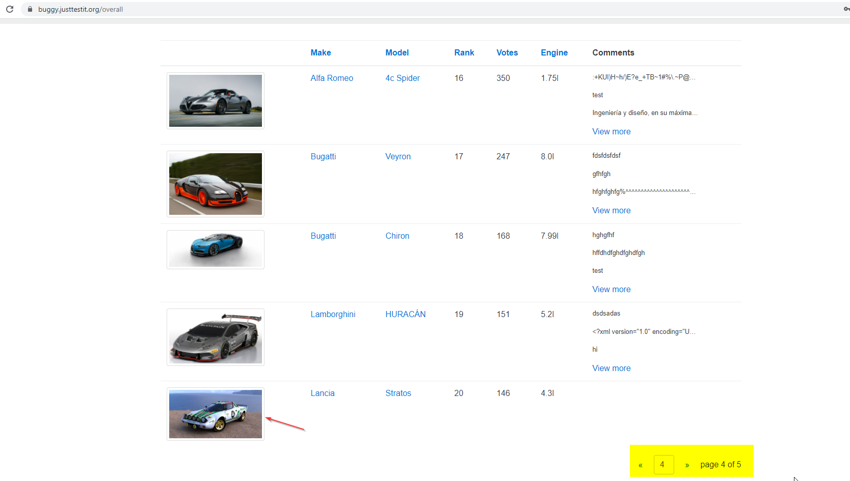

**Current Behaviour:**

Car image is not displayed, number votes is not displayed, engine and Max speed data is not displayed, no description of the Car is displayed, as below

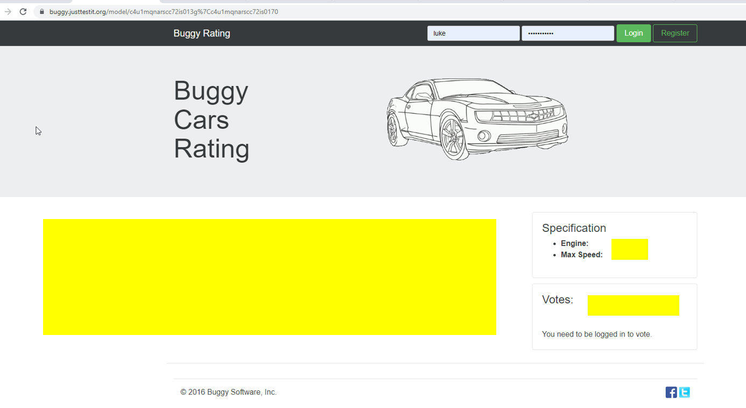

Click on Buggy Rating (Home page button), we see a blank Home page, as below

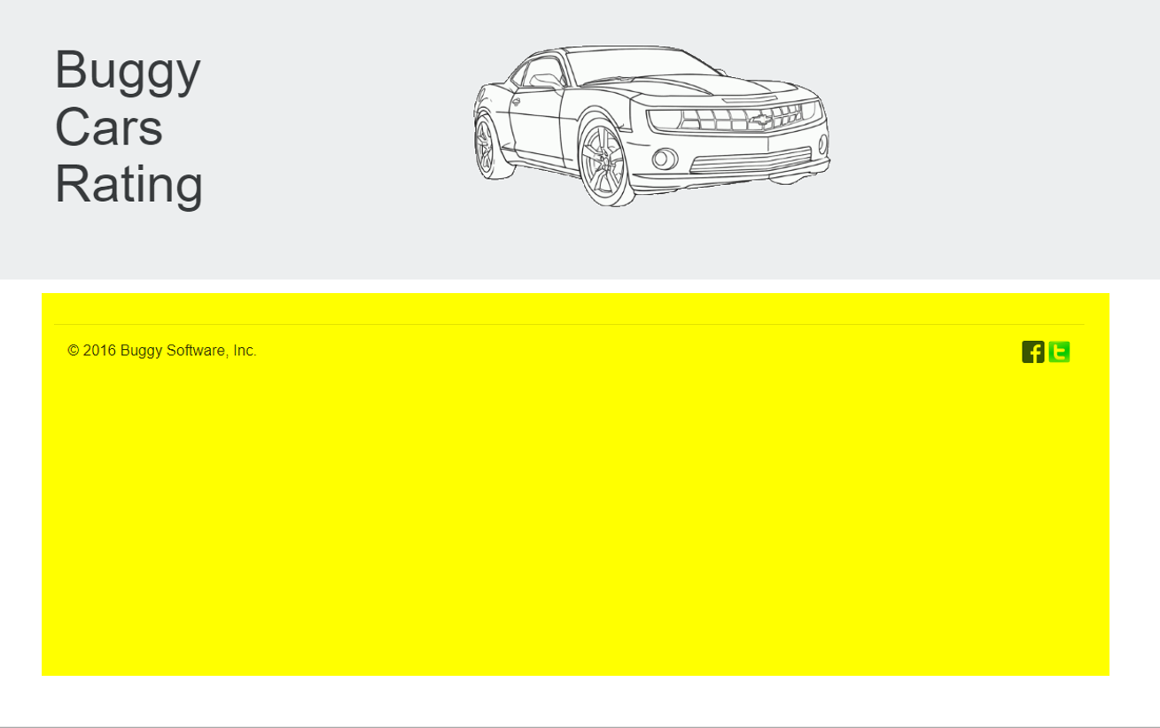

**Expected Behaviour:**

It should not display blank screen as above, it should display the expected Home page

**Defect 4: Pagination defect-user is able to navigate to page 6 of 5**

**Steps to reproduce:**

1. Navigate to Overall Rating Page from the home page(do not need to login)
2. Traverse to the last page(page 5 in this case) by clicking on ‘>>’

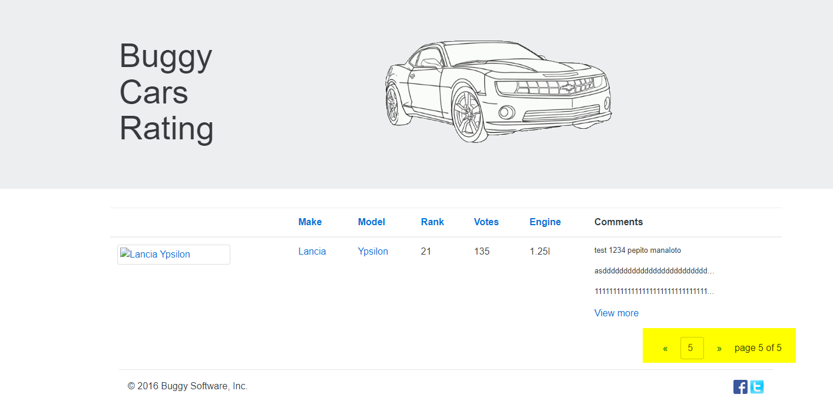

1. Click on ‘>>’

**Current Behaviour:**

User can go to pages (6, 7, 8 etc) more than page -5 with no data present in them

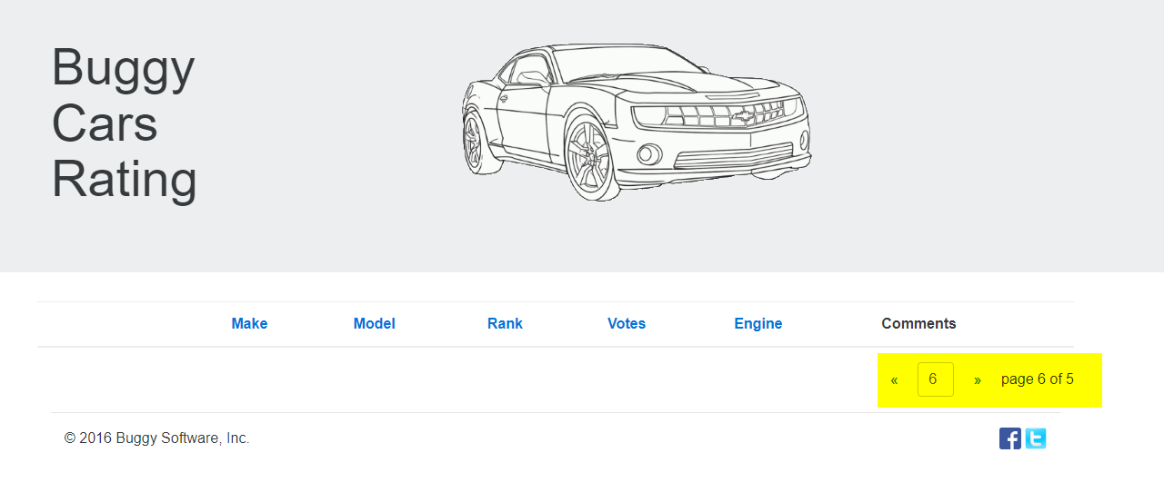

**Expected Behaviour:**

User should not be allowed to navigate to pages 6, 7, 8 etc, instead should be taken to page 1

**Defect 5: Responsiveness defect with the Home page**

**Steps to reproduce:**

1. Navigate to Home Page
2. Right-click on the landing page of the website to open the menu.
3. After the menu opens, click "Inspect"
4. Then click on the "Toggle device toolbar."
5. Test how adaptive the Home page for different devices

**Current Behaviour:**

As shown below, alignment of Popular Make is not matching with Popular model and Overall Rating tiles

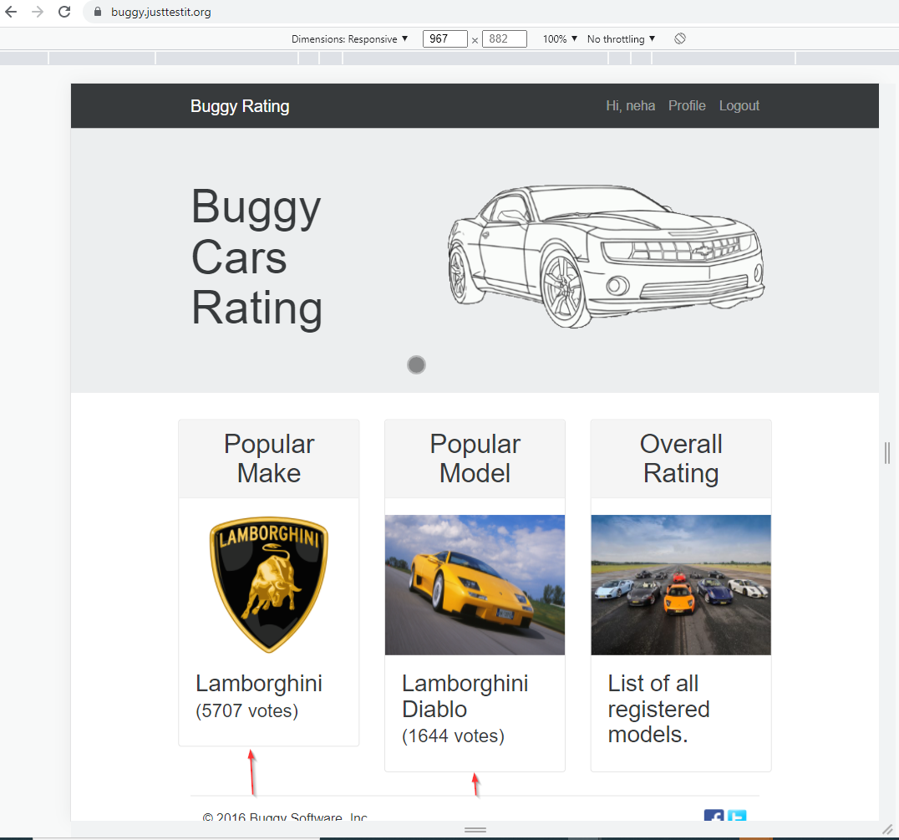

**Expected Behaviour:**

Different elements on the page should have uniform alignment

**Apart from these there are many other defects:**

* Home Page -> Popular Car Make page -> Click on Buggy Rating –Home Page button(the link is broken)
* Login form->validation message for Lastname field says “First Name is required”as below

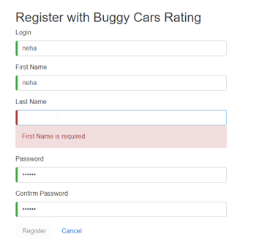

* Profile: Unknown error is displayed if we select knitting for hobby

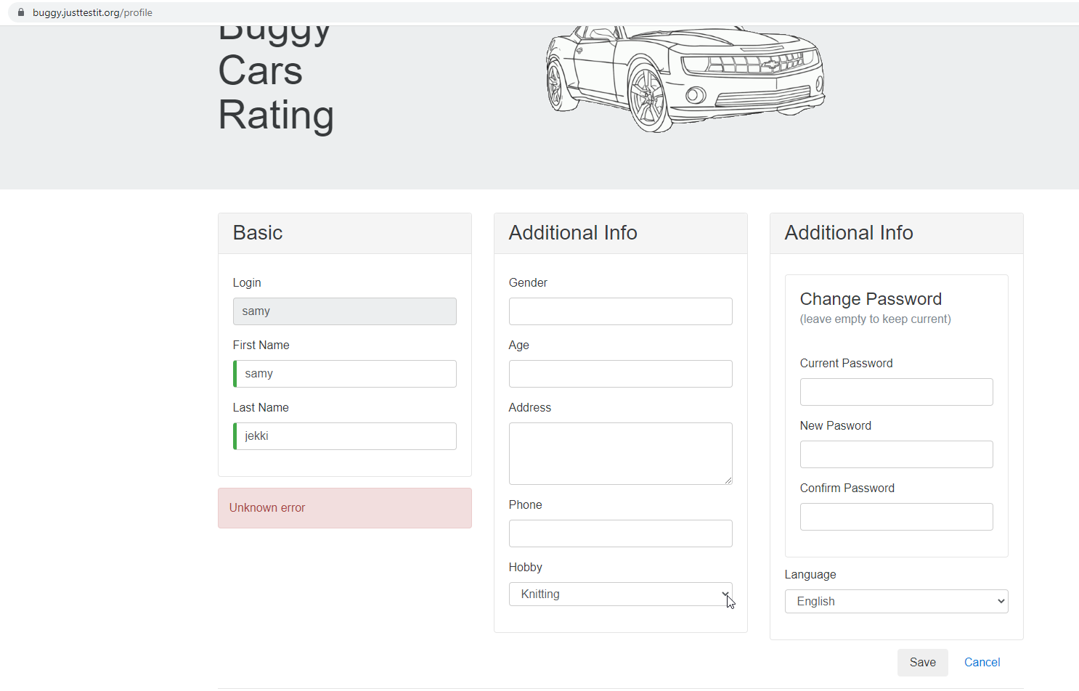

* Forgot Username option is missing
* User should be taken away from registration form to the Home page, once user completes registration successfully. Instead it displays another empty Registration form
* Language dropdown does not give any options

